I built a collaborative spreadsheet in C++ for the backend and C# for the frontend with a team of four. Nazy Krygier from Microsoft Talent Acquisition would schedule a thirty-minute call for me. The claim needs to exist because the resume can’t show a demo of the spreadsheet.

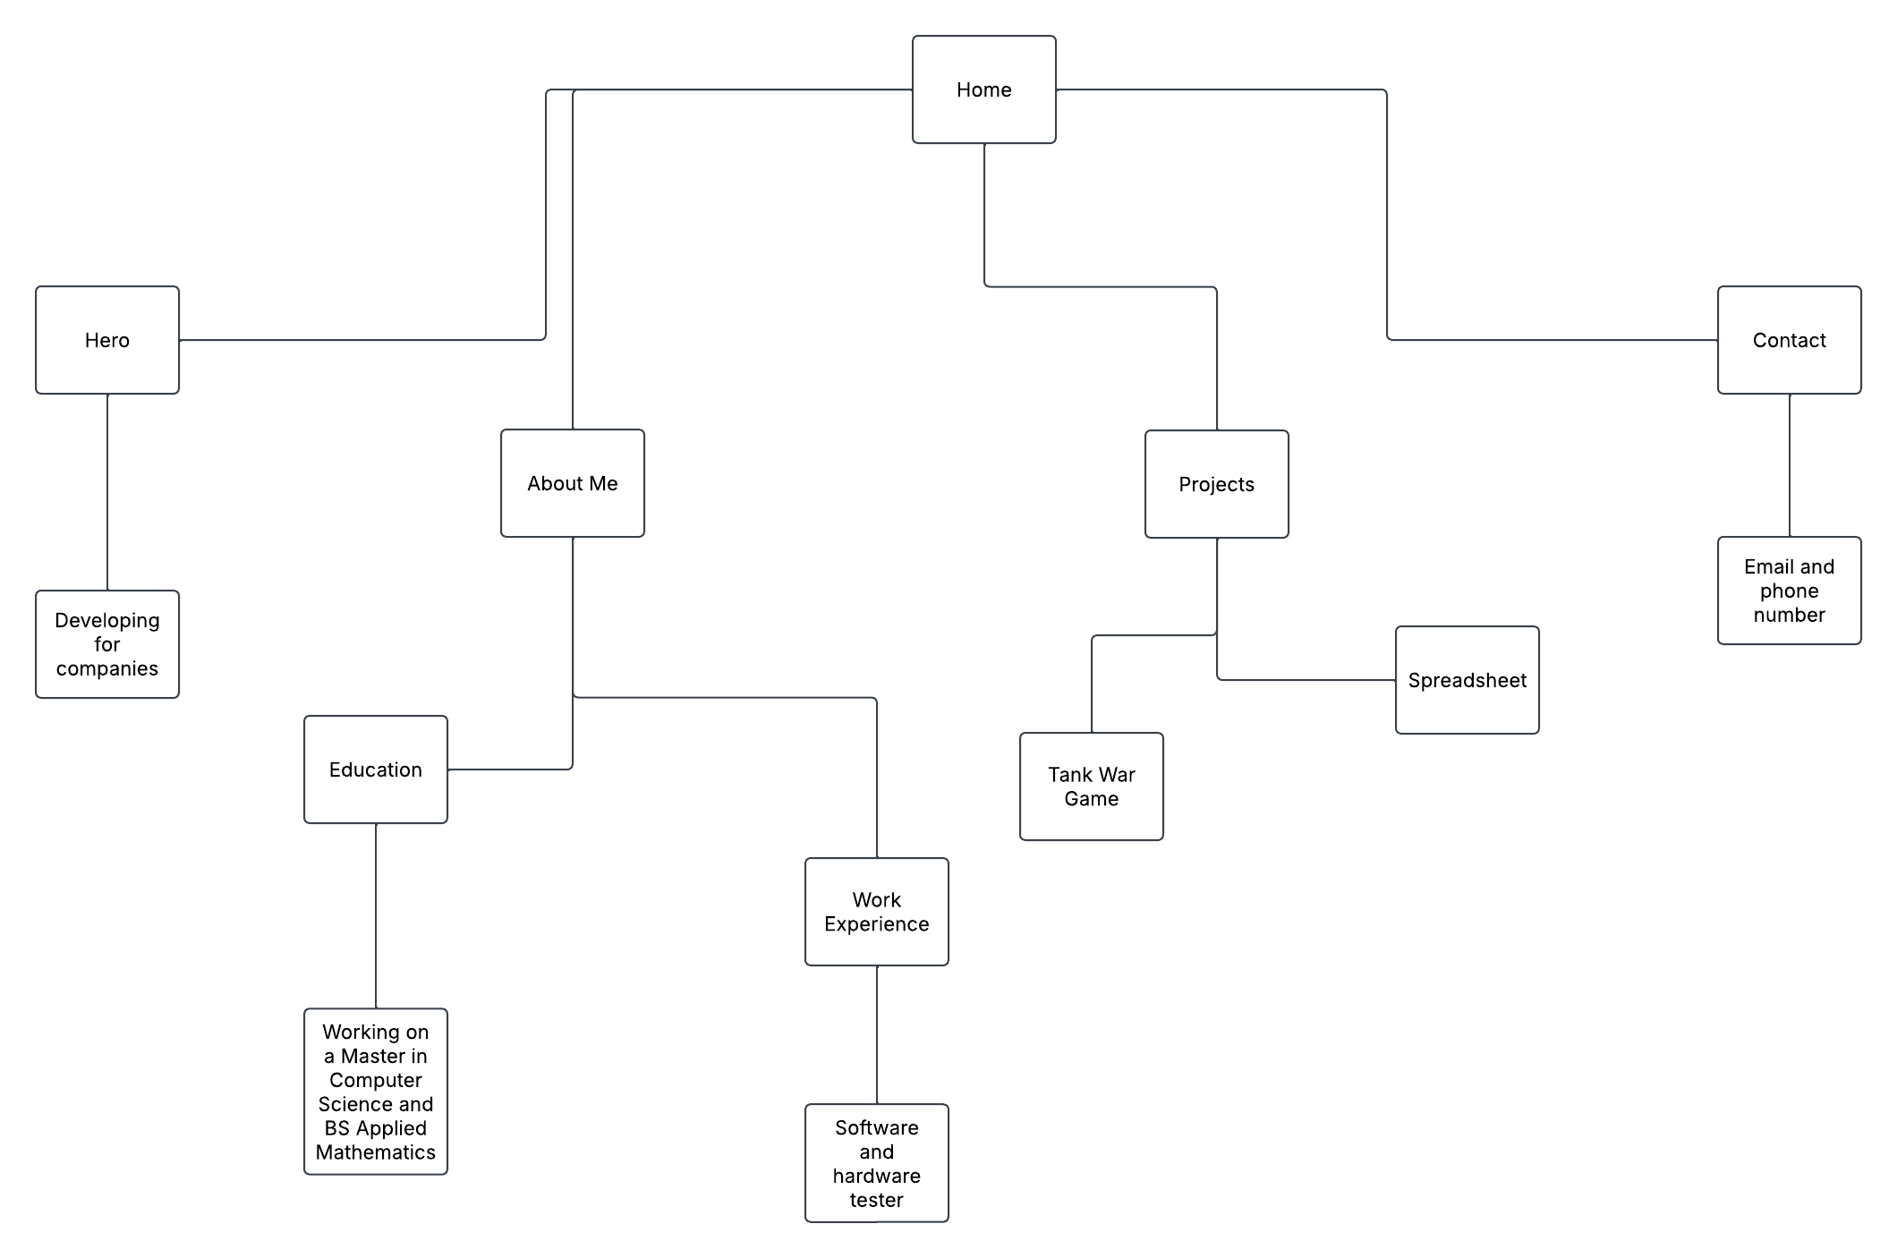

https://claude.ai/share/a9a5c55f-3861-4ef3-89d0-56dbeed473c6

